EXPERIMENT 17
AIM:
PERFORMANCE EVALUATION OF DIGITAL COMMUNICATION SYSTEMS USING EYE DIAGRAM ANALYSIS UNDER ADDITIVE WHITE GAUSSIAN NOISE (AWGN) USING MATLAB

SOFTWARE REQUIRED:
MATLAB Simulation

PROGRAM:
Clc;
Clear;
Close all;
N = 1000;
Sps = 20;
Data = randi([0 1],1,N);
X = 2*data-1;
Tx = repelem(x,sps);
% Add AWGN
R1 = tx + 0.2*randn(size(tx));
R2 = tx + 0.8*randn(size(tx));

Figure;
Subplot(3,1,1);
Plot(tx(1:400));
Title(‘Transmitted BPSK Signal’);
Grid on;

Subplot(3,1,2);
Eyediagram(r1(1:4000),2*sps);
Title(‘Eye Diagram with Low Noise’);

Subplot(3,1,3);
Eyediagram(r2(1:4000),2*sps);
Title(‘Eye Diagram with High Noise’);

GRAPH:
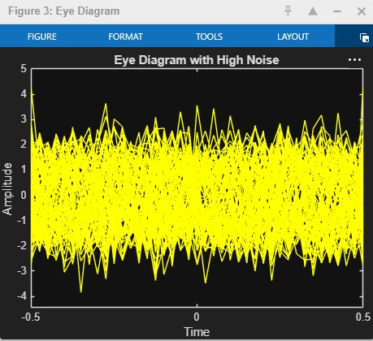
OUTPUT :
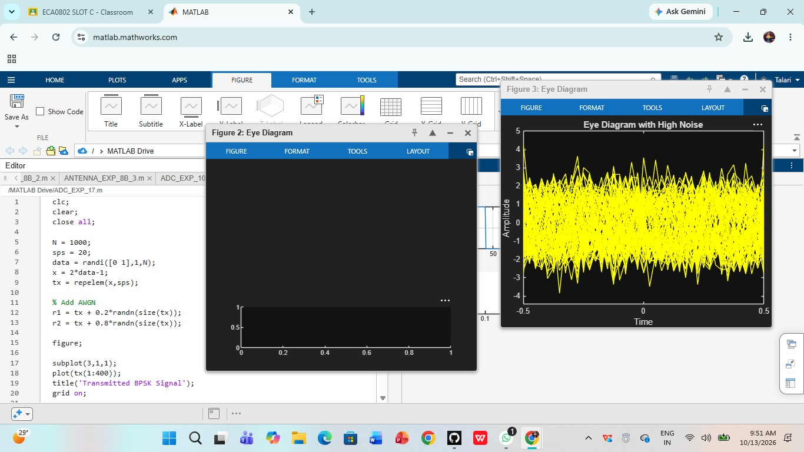

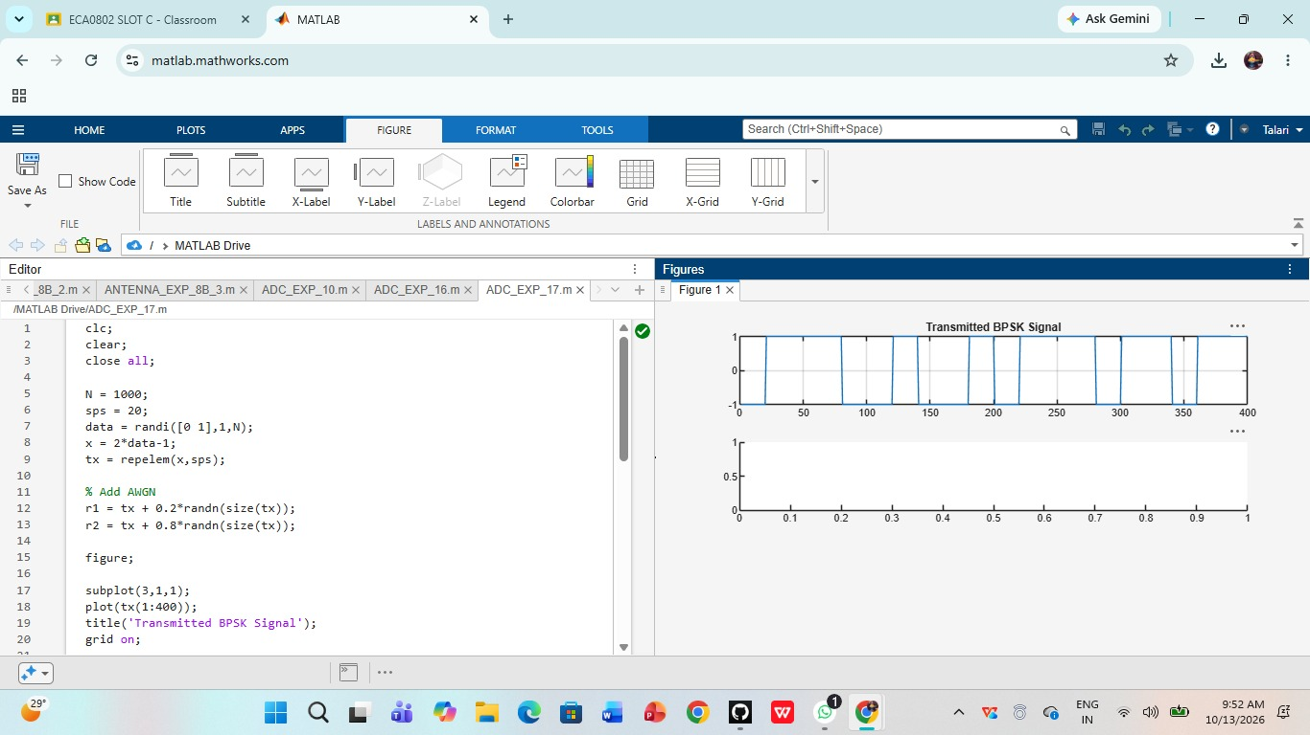

RESULT:
The eye diagram was successfully analyzed using MATLAB under AWGN. Increasing noise reduced the eye opening and degraded digital communication performance.

